Task 1:
#include <iostream>
#include <cstdlib> // For atoi function
#include <iomanip> // For setprecision function

using namespace std;

int main(int argc, char *argv[]) {
if (argc < 2) {
cout << "Usage: " << argv[0] << " <integer1> <integer2> ..." << endl;
return 1;
}

int sum = 0;
int numIntegers = argc - 1;
int* integers = new int[numIntegers];

// Convert command-line arguments to integers and calculate sum
for (int i = 0; i < numIntegers; ++i) {
integers[i] = atoi(argv[i + 1]);
if (integers[i] == 0 && argv[i + 1][0] != '0') { // Check for invalid input
cout << "Invalid input: " << argv[i + 1] << " is not an integer." << endl;
delete[] integers;
return 1;
}
sum += integers[i];
}

double average = static_cast<double>(sum) / numIntegers;

cout << "Sum: " << sum << endl;
cout << "Average: " << fixed << setprecision(2) << average << endl;

delete[] integers;
return 0;
}

OUTPUT:
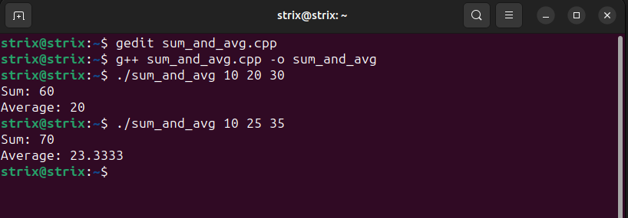

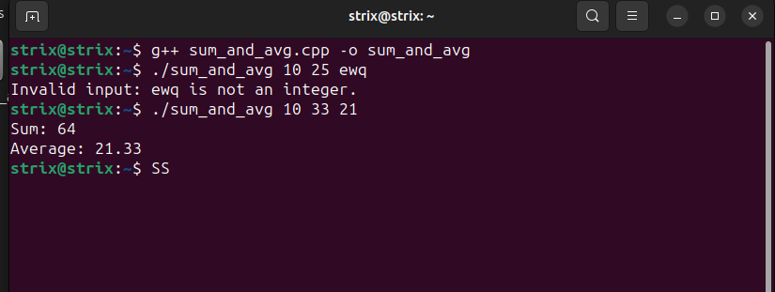
TASK 2:
#include <iostream>
#include <fstream>

using namespace std;

// Function to find the missing element in the series
int findMissingElement(int arr[], int n) {
int total = (n + 1) * (n + 2) / 2;
for (int i = 0; i < n; i++)
total -= arr[i];
return total;
}

int main(int argc, char *argv[]) {
if (argc < 4) {
cout << "Usage: " << argv[0] << " <series_length> <integer1> <integer2> ..." << endl;
return 1;
}

int seriesLength = atoi(argv[1]);
if (argc != seriesLength + 2) {
cout << "Invalid series length." << endl;
return 1;
}

int* series = new int[seriesLength];
for (int i = 0; i < seriesLength; ++i) {
series[i] = atoi(argv[i + 2]);
}

int missingElement = findMissingElement(series, seriesLength);

ofstream outputFile("missing_element.txt");
if (outputFile.is_open()) {
outputFile << "Missing element: " << missingElement << endl;
outputFile.close();
cout << "Missing element written to missing_element.txt" << endl;
} else {
cout << "Unable to open file for writing." << endl;
}

delete[] series;
return 0;
}

OUTPUT:
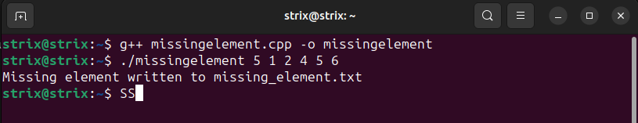
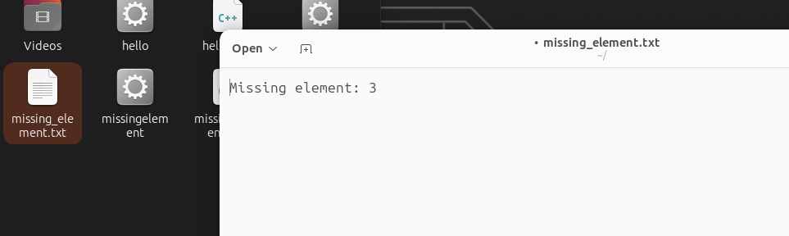

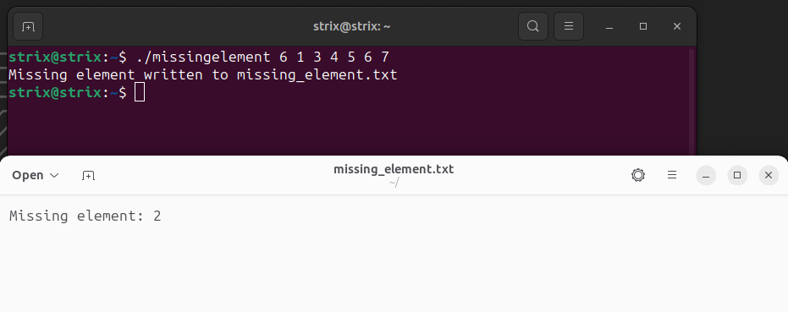
TASK 3:
#include <iostream>
#include <fstream>
#include <vector>

using namespace std;

int findMissingElement(const vector<int>& series, int expectedSize) {
int total = (expectedSize * (expectedSize + 1)) / 2;
for (int num : series)
total -= num;
return total;
}

int main(int argc, char *argv[]) {
if (argc != 3) {
cout << "Usage: " << argv[0] << " <input_file> <output_file>" << endl;
return 1;
}

string inputFile = argv[1];
string outputFile = argv[2];

ifstream input(inputFile);
if (!input.is_open()) {
cout << "Unable to open input file." << endl;
return 1;
}

vector<int> series;
int num;
while (input >> num) {
series.push_back(num);
}
input.close();

// Expected size of the series is one more than the size of the vector
int expectedSize = series.size() + 1;
int missingElement = findMissingElement(series, expectedSize);

ofstream output(outputFile);
if (!output.is_open()) {
cout << "Unable to open output file." << endl;
return 1;
}

output << "Missing element: " << missingElement << endl;
output.close();

cout << "Missing element written to " << outputFile << endl;

return 0;
}

OUTPUT:
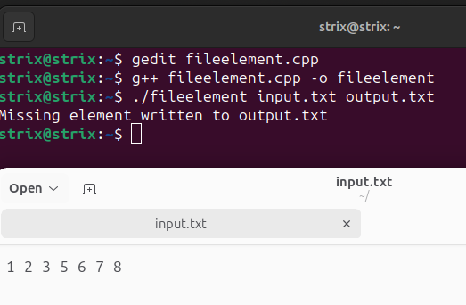
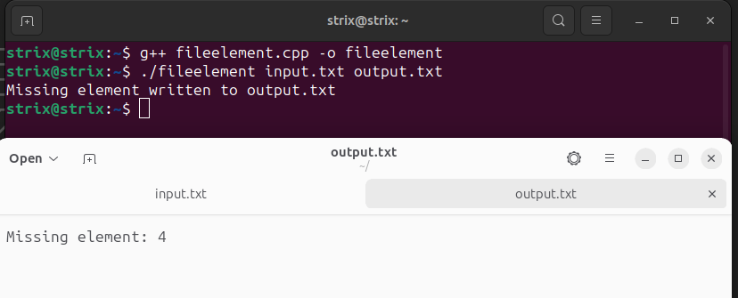
TASK 4:
Lettercount.cpp
#include "LetterCount.h"

using namespace std;

LetterCount::LetterCount() : count(0) {}

void LetterCount::countLetters(const string& filename) {
ifstream file(filename);
if (!file.is_open()) {
cerr << "Error: Unable to open file " << filename << endl;
return;
}

char ch;
while (file.get(ch)) {
if (isalpha(ch)) {
count++;
}
}

file.close();
}

int LetterCount::getCount() const {
return count;
}

Lettercount.h
#ifndef LETTERCOUNT_H
#define LETTERCOUNT_H

#include <iostream>
#include <fstream>

class LetterCount {
private:
int count;
public:
LetterCount();
void countLetters(const std::string& filename);
int getCount() const;
};

#endif

Linecount.h
#ifndef LINECOUNT_H
#define LINECOUNT_H

#include <iostream>
#include <fstream>
#include <string>

class LineCount {
private:
int count;
public:
LineCount();
void countLines(const std::string& filename);
int getCount() const;
};

#endif

Linecount.cpp
#include "LineCount.h"

using namespace std;

LineCount::LineCount() : count(0) {}

void LineCount::countLines(const string& filename) {
ifstream file(filename);
if (!file.is_open()) {
cerr << "Error: Unable to open file " << filename << endl;
return;
}

string line;
while (getline(file, line)) {
count++;
}

file.close();
}

int LineCount::getCount() const {
return count;
}

Wordcount.h
#ifndef WORDCOUNT_H
#define WORDCOUNT_H

#include <iostream>
#include <fstream>
#include <string>

class WordCount {
private:
int count;
public:
WordCount();
void countWords(const std::string& filename);
int getCount() const;
};

#endif

Wordcount.cpp
#include "WordCount.h"

using namespace std;

WordCount::WordCount() : count(0) {}

void WordCount::countWords(const string& filename) {
ifstream file(filename);
if (!file.is_open()) {
cerr << "Error: Unable to open file " << filename << endl;
return;
}

string word;
while (file >> word) {
count++;
}

file.close();
}

int WordCount::getCount() const {
return count;
}

Main.cpp
#include <iostream>
#include "LetterCount.h"
#include "WordCount.h"
#include "LineCount.h"

using namespace std;

int main() {
LetterCount letterCounter;
letterCounter.countLetters("example.txt");
cout << "Number of letters: " << letterCounter.getCount() << endl;

WordCount wordCounter;
wordCounter.countWords("example.txt");
cout << "Number of words: " << wordCounter.getCount() << endl;

LineCount lineCounter;
lineCounter.countLines("example.txt");
cout << "Number of lines: " << lineCounter.getCount() << endl;

return 0;
}

OUTPUT:
